

External User Adding a Wind Surgery

Maintain Colour and Sex

16th November 2017

Meg Beattie

Version 1

Contents

1.0 Background: 3

2.0 Types of Wind Surgery: 3

3.0 Adding a Wind Surgery: 4

3.1 Step 1 Wind Surgery Details 6

3.2 Step 2: Review Details 7

3.3 Step 3. Receipt 8

4.0 Horse and Veterinary Tab 10

5.0 Maintaining Colour and Sex 10

5.1 Step 1 Maintain Colour and Sex 12

5.2 Step 2 Review 13

5.3 Step 3. Receipt 14

# 1.0 Background:

Racecards will carry information that confirms when a horse is having its first run after a wind surgery.

The declaration of wind surgeries will only be required for horses which have previously raced, regardless of whether the previous race(s) were in Great Britain or elsewhere. The declaration of a wind surgery will be required prior to declarations for the horse’s first race start after it has been subjected to wind surgery. Where a horse is subjected to wind surgery on multiple occasions the declaration will be required on each occasion.

Wind operations are relatively simple surgical procedures which are designed to assist a horse with its breathing. We have identified a list of five of the most relevant and frequent surgeries, which we are asking trainers to declare.

# 2.0 Types of Wind Surgery:

The types of wind surgery required to be declared are:

* Tie back (prosthetic laryngoplasty)
* Hobday (ventriculectomy/cordectomy)
* Epiglottic surgery
* Tie forward (dorsal displacement soft palate surgery)
* Soft palate cautery

# 3.0 Adding a Wind Surgery:

* External users (Trainers or Trainers sub-agents only) will be able to add a Wind Surgery into the system. The wind surgery will only be able to be added on the day or historically, never for a future date.

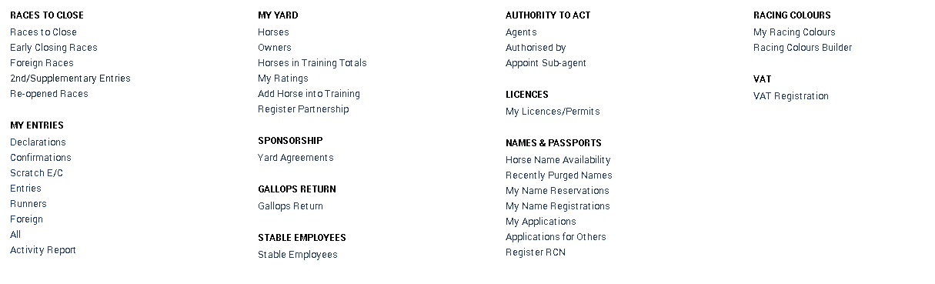

* The user must then select the animal they wish to add a Wind Surgery against
* This will take the user to the page displayed below
* The user will need to select the Horse and Veterinary Tab

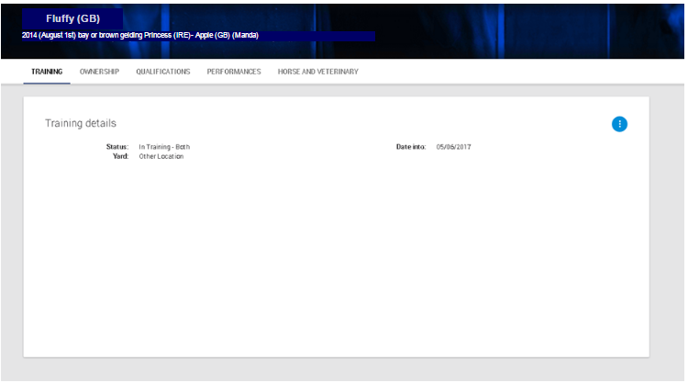

* Once the Horse and Veterinary tab has been selected the user will be able to see any veterinary details that currently exist on the system.
* To add a Wind Surgery onto the horse the user must select the 3-dot blue button, then select “Add Wind Surgery”.

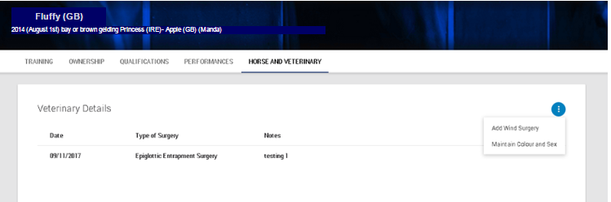

# 3.1 Step 1 Wind Surgery Details

The user will be required to fill in the following:

* Type of Surgery performed on the horse can be selected from the drop-down list
* The date of the surgery can be selected from the calendar picker
* Any further notes that the user may wish to include such as “Surgery went well. Vet returning Thursday 7th December for a follow up appointment.” By typing in the text box.
* User must select “Continue” to get to the next step.
* The user can select “Cancel” to remove themselves from the flow.
* If “Cancel” is selected, a pop up will show saying, “Are you sure?”
* if the user selects “Yes” it will cancel you out of the flow and take you back to the Horse page. If “No” is selected then it will cancel the pop up and the user will be able to continue to Step 2.

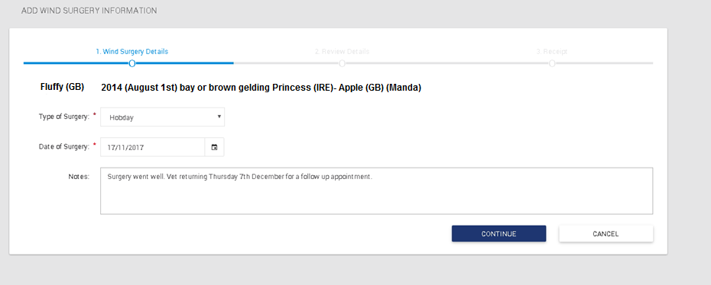

# 3.2 Step 2: Review Details

* Step 2 will display all of the information entered in Step 1.
* At this point if you wish to amend any of the information entered in Step 1 the user will be able to select the tube stops at the page.
* If the user is happy with the information entered they will need to select “Submit”
* The user can select “Cancel” to remove themselves from the flow.
* If “Cancel” is selected, a pop up will show saying, “Are you sure?”
* if the user selects “Yes” it will cancel you out of the flow and take you back to the Horse page.
* If “No” is selected then it will cancel the pop up and the user will be able to continue to Step 3

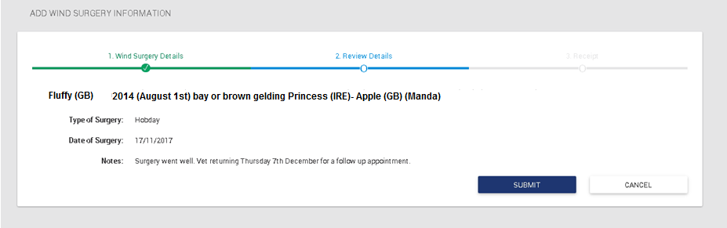

# 3.3 Step 3. Receipt

* Once “Submit” has been selected the user will be shown Step 3
* Step 3 will display the same information that was entered in the previous step but the information will no longer be able to be edited
* There will a link in the bottom right hand corner which when selected, will take the user back to the Horse and Veterinary Tab.

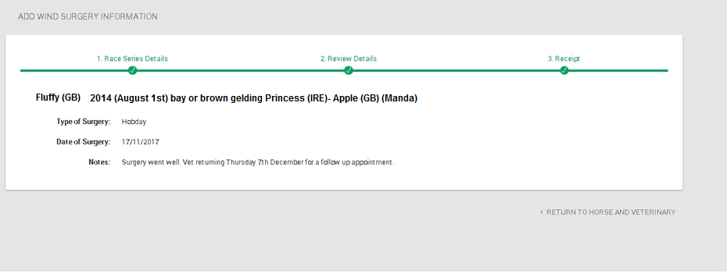

# 4.0 Horse and Veterinary Tab

* The tab will now show the added surgery and also any other previous surgeries that have been entered.

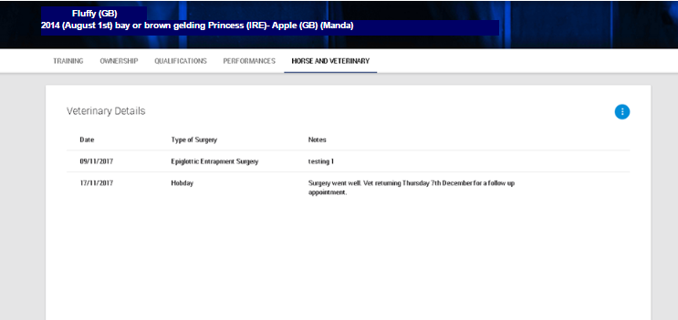

# 5.0 Maintaining Colour and Sex

* If the user wishes to maintain the Colour and Sex of a horse, they will need to progress to the Horse and Veterinary tab and then select the 3-dot blue button.

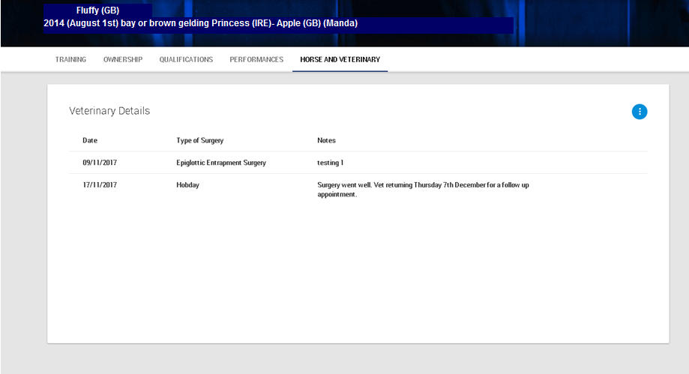

# 5.1 Step 1 Maintain Colour and Sex

* The user will be allowed to amend the sex, if possible, from the drop-down list (e.g. Colt to Gelding).
* The user will also be able to amend the colour from the drop-down box provided- again, if this is a viable option.

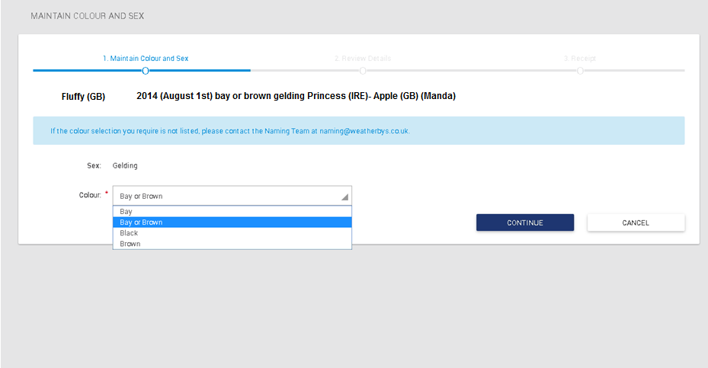

* User must select “Continue” to get to the next step.
* The user can select “Cancel” to remove themselves from the flow.
* If “Cancel” is selected, a pop up will show saying, “Are you sure?”
* if the user selects “Yes” it will cancel you out of the flow and take you back to the Horse page. If “No” is selected then it will cancel the pop up and the user will be able to continue to Step 2.

# 5.2 Step 2 Review

* Step 2 will display all of the information entered in Step 1.
* At this point if you wish to amend any of the information entered in Step 1 the user will be able to select the tube stops at the page.
* If the user is happy with the information entered they will need to select “Submit”
* The user can select “Cancel” to remove themselves from the flow.
* If “Cancel” is selected, a pop up will show saying, “Are you sure?”
* if the user selects “Yes” it will cancel you out of the flow and take you back to the Horse page.
* If “No” is selected then it will cancel the pop up and the user will be able to continue to Step 3

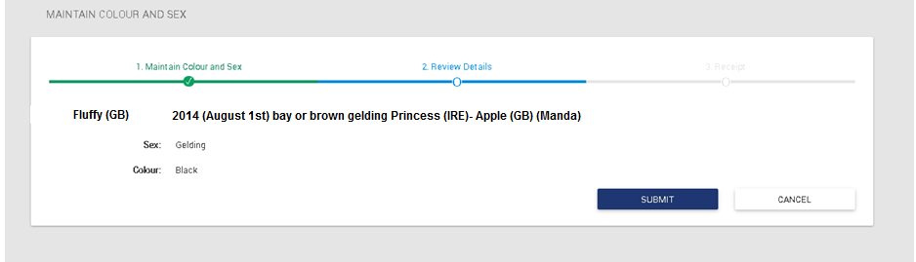

# 5.3 Step 3. Receipt

* Once “Submit” has been selected the user will be shown Step 3
* Step 3 will display the same information that was entered in the previous step but the information will no longer be able to be edited
* There will a link in the bottom right hand corner which when selected, will take the user back to the Horse and Veterinary Tab.

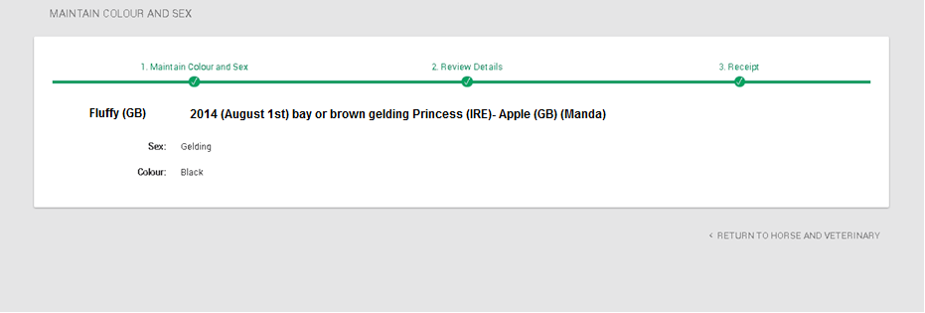

* The tab will now show the updated Colour and Sex information in the top banner of the page.



* If the user has made an error with the information entered, they will be unable to amend it themselves. They will need to contact Weatherbys in order to amend it.